Data Flow Diagram (DFD) depicts the flow of information and the transformation applied when data moves in and out of a system. The overall system is represented and described using input, processing, and output in the DFD. The inputs can be:
- Book request when a student requests for a book.
- Library card when the student has to show or submit his/her identity as proof.
The overall processing unit will contain the following output that a system will produce or generate:
- The book will be the output as the book demanded by the students will be given to them.
- Information on the demanded book should be displayed by the library information system that can be used by the student while selecting the book which makes it easier for the student.
- Level 0 DFD –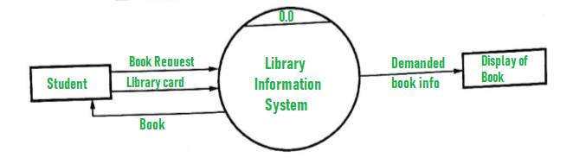
- Level 1 DFD – At this level, the system has to show or exposed with more details of processing. The processes that are important to be carried out are:
  - Book delivery
  - Search by topic
List of authors, List of Titles, List of Topics, the bookshelves from which books can be located are some information that is required for these processes. Data store is used to represent this type of information.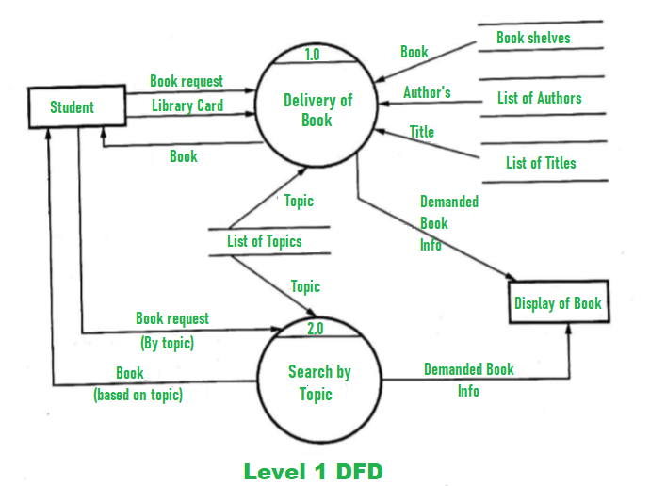
- Level 2 DFD –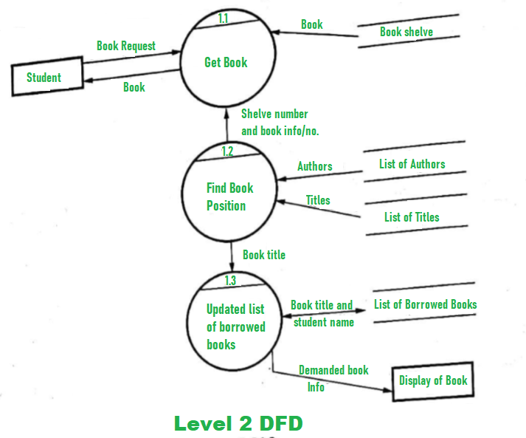
Out of scope:
Other activities like purchasing of new books, replacement of old books or charging a fine are not considered in the above system.

Data flow diagram(DFD) for Online shopping website
A data flow diagram is a graphical view of how data is processed in a system in terms of input and output.
The Data flow diagram (DFD) contains some symbol for drawing the data flow diagram.

Data flow diagram symbol
Symbol | Description
 | Data Flow – Data flow are pipelines through the packets of information flow.
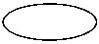 | Process : A Process or task performed by the system.
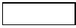 | Entity : Entity are object of the system. A source or destination data of a system.
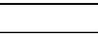 | Data Store : A place where data to be stored.

Context level DFD – 0 level
The context level data flow diagram (dfd) is describe the whole system. The (o) level dfd describe the all user module who operate the system. Below data flow diagram of online shopping site shows the two user can operate the system Admin and Member user.
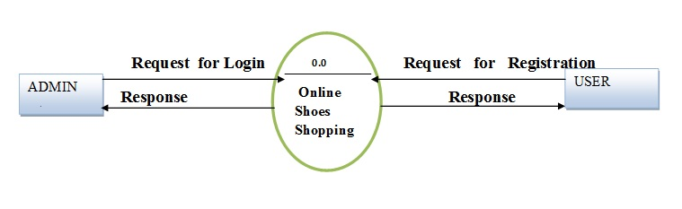o – Level DFD for Online shopping website project

1st Level Admin Side DFD
The Admin side DFD describe the functionality of Admin, Admin is a owner of the website. Admin can first add category of item and then add items by category wise. and admin can manage order and payment detail.
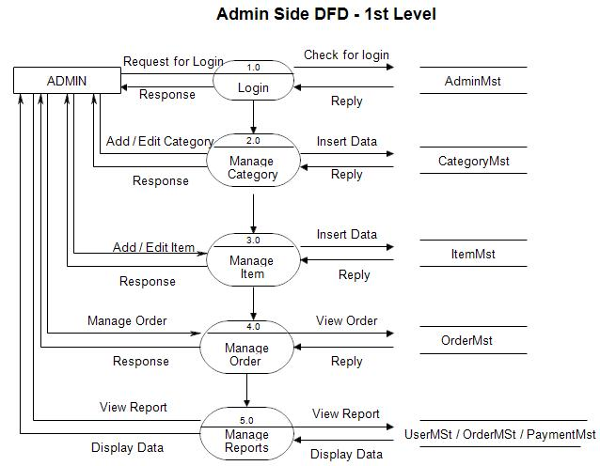1st Level – Admin Side Data Flow Diagram

2nd Level – Admin side DFD (3.0)
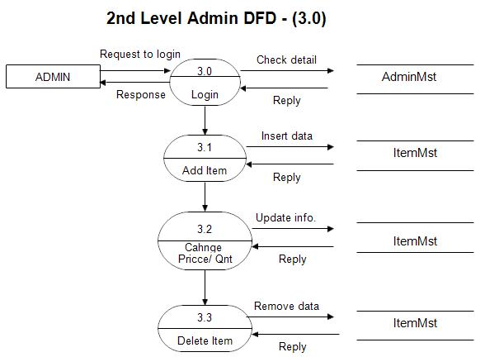DFD for online shopping website project

2nd Level – Admin side DFD (4.0)
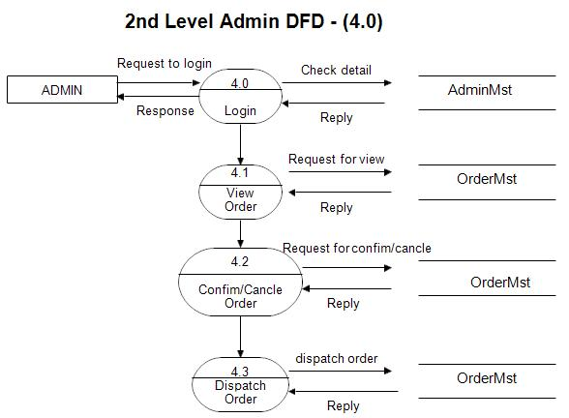Admin side DFD for online shopping website project

2nd Level – Admin side DFD (5.0)
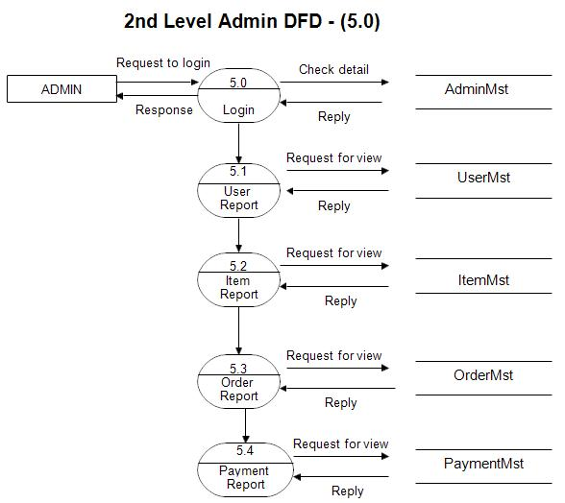Admin side DFD for online shopping website project

1st level – User side Data flow Diagram
The user is all people who operate or visit our website. User is a customer of a website. User can first select product for buy, user must have to register in our system for purchase any item from our website. after register he can login to site and buy item by making online payment through any bank debit card or credit card.
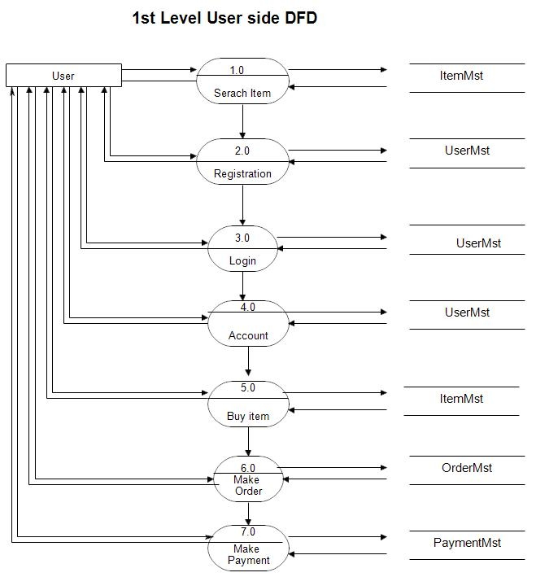User side DFD for online shopping website project

2nd level – User side DFD (4.0)
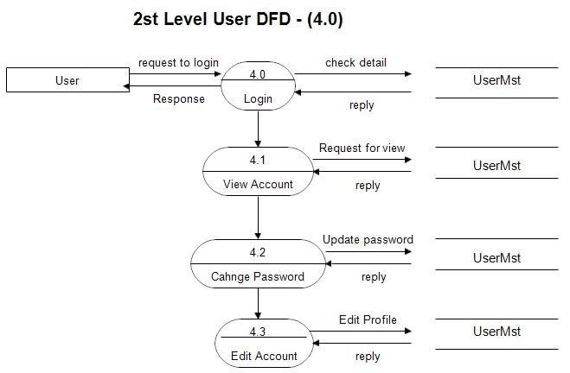User side DFD for online shopping website project

2nd level – User side DFD (5.0)
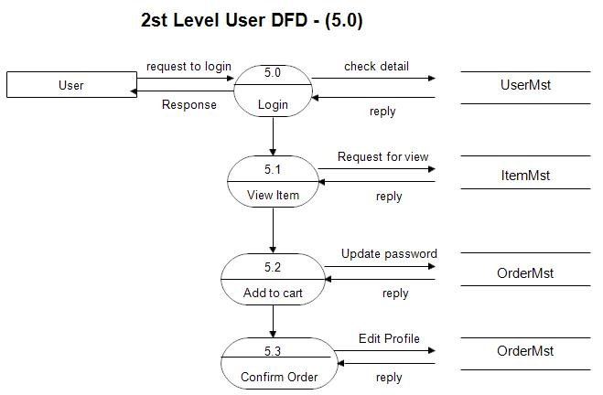DFD for online shopping website project

What is Online Shopping System DFD?
The Online Shopping System Data Flow Diagram (DFD) is like a picture that shows how information moves in online stores. It tells us about things like how we choose products, pay for them, and how orders get processed. It's made of simple pictures and arrows to make it easy to understand. By creating a context diagram for online shopping system, it helps us see and study how online shopping works, making it simpler for everyone.

Basic Data Flow Diagram Symbols
Before we explore the details of creating dfd diagram for online shopping, let's first understand the key symbols used in a Data Flow Diagram for online shopping system:
- Data Flow: A Data Flow in a diagram is like a pathway that shows how information moves from one place to another. It could be when you choose a product online and it goes into your shopping cart.
- Process: The Process symbol represents an action or task. In an online shopping diagram, it could be something like when you pay for the items in your cart. It shows what happens to the information.
- Entity: An Entity is something like a group or a person. In an online shopping diagram, it might represent you as a customer. It shows who is involved in the process.
- Data Store: A Data Store is like a storage place where information is kept. In online shopping, this could be where details about products or your order are saved. It's like a virtual shelf where things are kept until they're needed.

Levels of DFD Online Shopping System
Before we explore the intricacies of each level, it's important to understand that Data Flow Diagrams (DFDs) are like blueprints, showing how information moves through an online shopping system.

- DFD Level 0 Online Shopping System
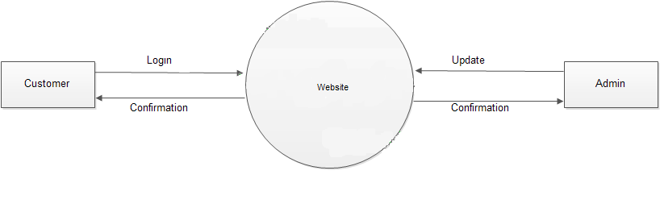
The dfd level 0 for online shopping offers an overall view of how online shopping works, highlighting essential components like customers, admin, and websites.

- Level 1 DFD for Online Shopping System
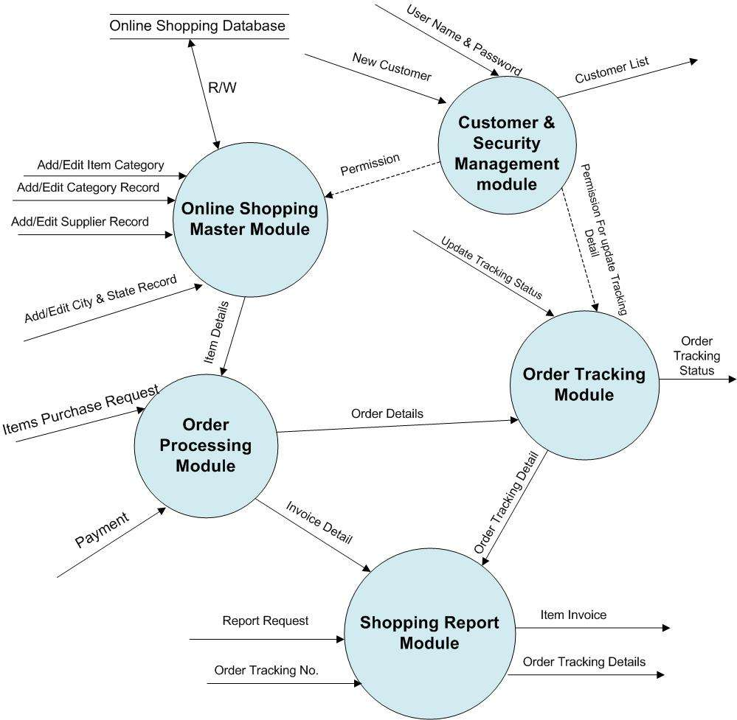
Level 1 DFD heads deeper, providing detailed insights into processes like product selection, order processing modules, and payment, giving a closer look at each step.

- Level 2 DFD for Online Shopping System
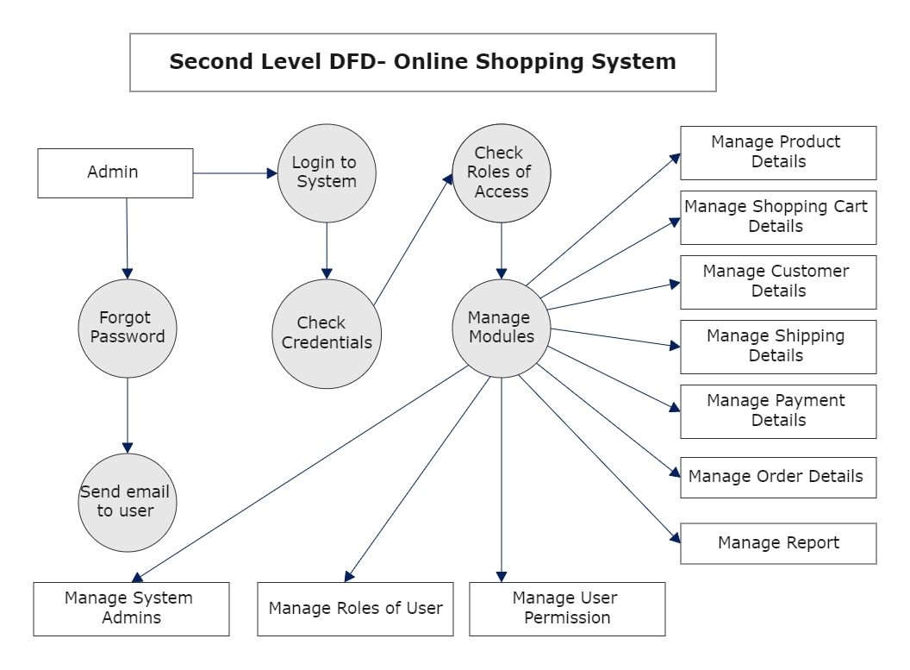
Level 2 DFD takes a finer approach, offering highly specific details, such as the step-by-step breakdown of the payment process, and checking user credentials, allowing for a meticulous understanding.
Food Ordering System is actually a type of software that allows the manager of restaurants to manage and accept the placed orders over the Internet or in the restaurant. Let us understand the working of the food ordering system by using DFD (Data Flow Diagram). DFD for Food Ordering System is shown below.
Here, different levels of DFD are shown for Food Ordering System such as Level 0 DFD, Level 1 DFD, Level 2 DFD, and Level 3 DFD.
- Level 0 DFD –
At this level, the Input and Output of the system are shown. The system is designed and established across the world with input and output at this level.
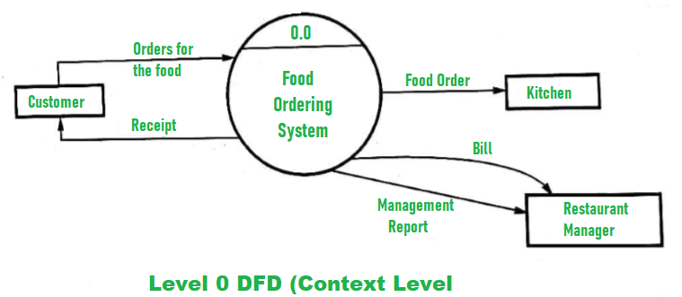
Food Ordering System has the following input :
  - Food order is input as the customer’s order for food.
Food Ordering System has the following output:
  - Receipt of the order.
  - For further processing the order, the food order is passed to the kitchen.
  - The restaurant manager gets the report of Bill and Management.

- Level 1 DFD –
For processing the order, process 1.0 is responsible. For food, the housekeeping activities involved are represented by processes 2.0, 3.0, and 4.0. The detailed information about daily sold items should be available to create and report management and the list of items that are available ‘in-stock’ should be kept by maintaining the inventory data (describes the records of datasets such as their name, their content, source, many useful information, etc.) at the same time.
Hence, two data stores are used in this level of DFD given below :
  - Database of Sold items
  - Inventory database
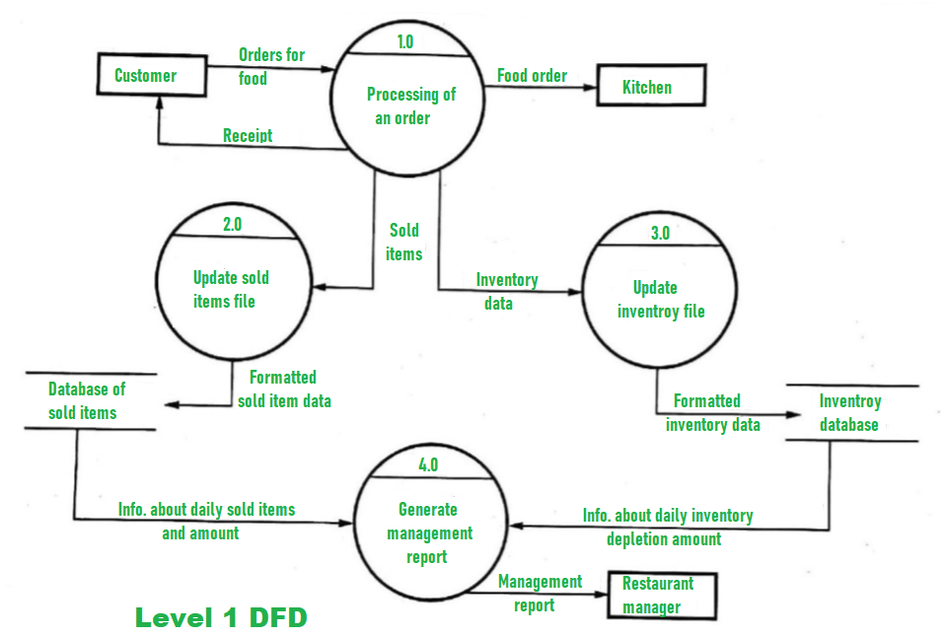
In the end, with the use of the amount of daily sold items and daily inventory depletion, it is easy to prepare a report of management. Further, the restaurant manager gets this report of management.

- Level 2 DFD –
Detailed information about “Processing of an Order” is shown below :
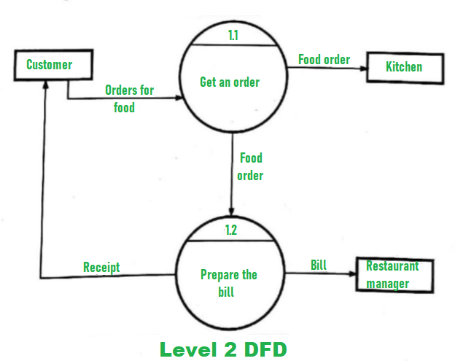

- Level 3 DFD –
More detailed information about the activity of the “Generate Management Report” is given at this level of DFD. Having access to data of sold items and data of inventory should be available for generating the report of management. Then, both data of solid items and data of inventory need to be aggregated after which the restaurant manager should get the report of management that is prepared from the above calculations.
The above details are shown below:
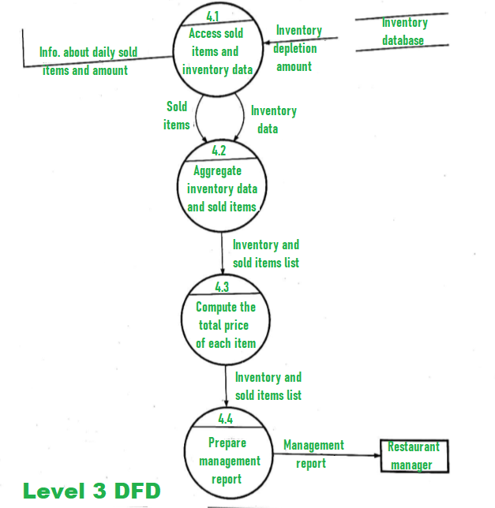
DFD (Data Flow Diagram) of an ATM System consist of two levels of DFD. These levels are Level 0 DFD and Level 1 DFD. Both these levels are used for making the DFD of an ATM system.
- Level 0 DFD :
This level is also known as Context Level DFD. At this level, only the interacting inputs and outputs with a system are described. The DFD of this level is shown below:
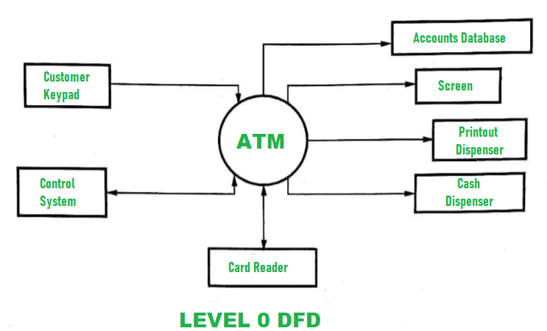
- Level 1 DFD :
At this level, more detailed information is given about the processing of the ATM system. The DFD of this level is shown below:
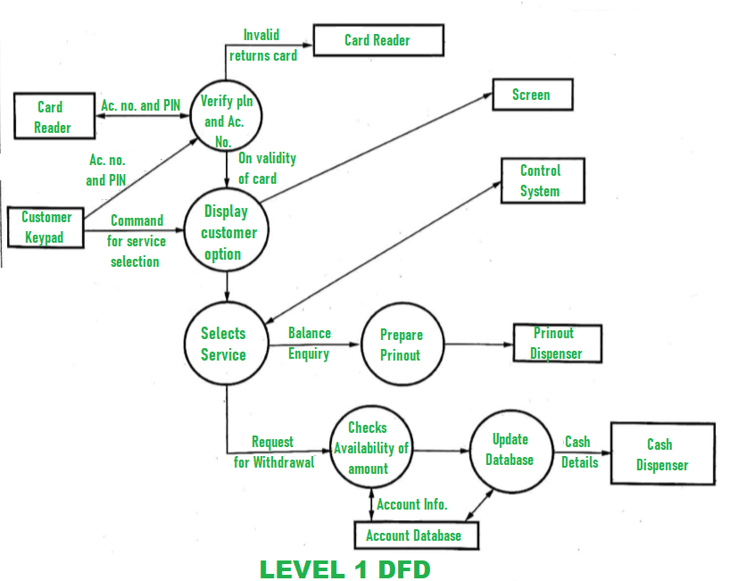
USE CASE DIAGRAM

Automated Teller Machine (ATM) also known as ABM (Automated Banking Machine) is a banking system. This banking system allows customers or users to have access to financial transactions. These transactions can be done in public space without any need for a clerk, cashier, or bank teller. Working and description of the ATM can be explained with the help of the Use Case Diagram.
We will understand about designing the use case diagram for the ATM system. Some scenarios of the system are as follows.
- Step-1:
The user is authenticated when enters the plastic ATM card in a Bank ATM. Then enters the user name and PIN (Personal Identification Number). For every ATM transaction, a Customer Authentication use case is required and essential. So, it is shown as include relationship.
Example of use case diagram for Customer Authentication is shown below:
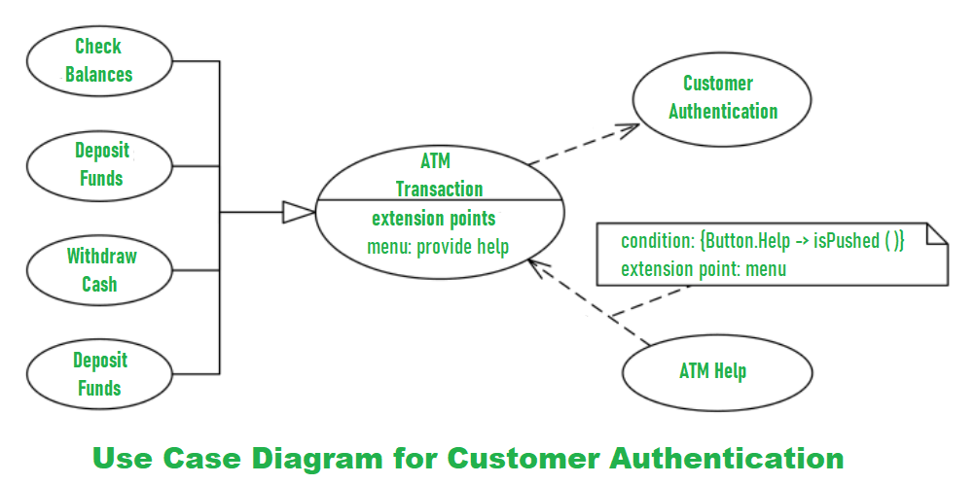
- Step-2:
User checks the bank balance as well as also demands the mini statement about the bank balance if they want. Then the user withdraws the money as per their need. If they want to deposit some money, they can do it. After complete action, the user closes the session.
Example of the use case diagram for Bank ATM system is shown below:
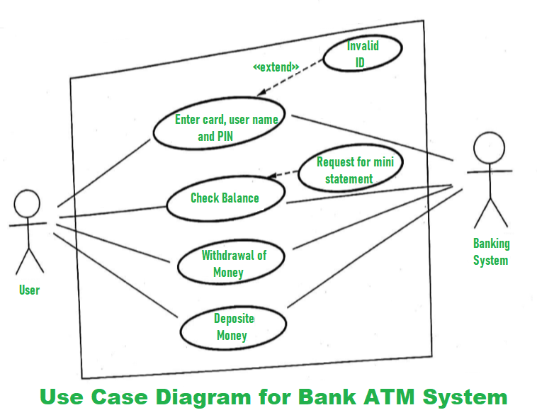
- Step-3:
If there is any error or repair needed in Bank ATM, it is done by an ATM technician. ATM technician is responsible for the maintenance of the Bank ATM, upgrades for hardware, firmware or software, and on-site diagnosis.
Example of use case diagram for working of ATM technician is shown below:
